**Management System Document – Guidance Note**

**Design for Signalised Junctions**

**Document reference: SQA-0643 - issue: 2**

**1 Purpose**

1.1 The purpose of this document is to provide guidance for the design of signalised junctions in London.

**2 Scope**

2.1 This guidance note applies to all signalised junctions in London

**3 Design Considerations**

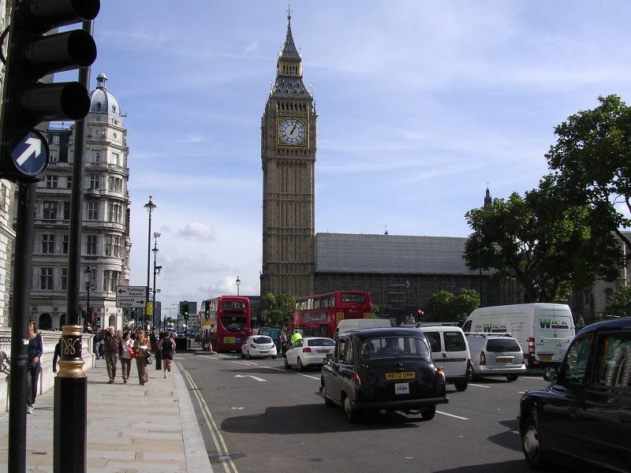

3.1 General

3.1.1 The standards outlined in TD 50/04 shall apply to all new junctions which are signal-controlled, signalised roundabouts and to all existing uncontrolled priority junctions, which are being modified or improved to operate with signal control.

The advice in this document is sets out the standards, design criteria and good practice for Designers when modifying existing signalised junctions. Where signal control is installed for safety reasons and where there are constraints perhaps due to the existing road layout and surroundings (a typical situation in London), the design standards in TD 50/04 should be incorporated where possible.

3.2 Geometric Considerations of Primary and Secondary Signals (see TD50/04, TAL1/06, TAL 2/03)

3.2.1 The Traffic Signs Regulations and Directions 2002 instrument (TSRGD 2002) requires all junctions to have at least two identical sets of signals facing the traffic proceeding in a particular direction, where one of those is a primary signal (Direction 55).

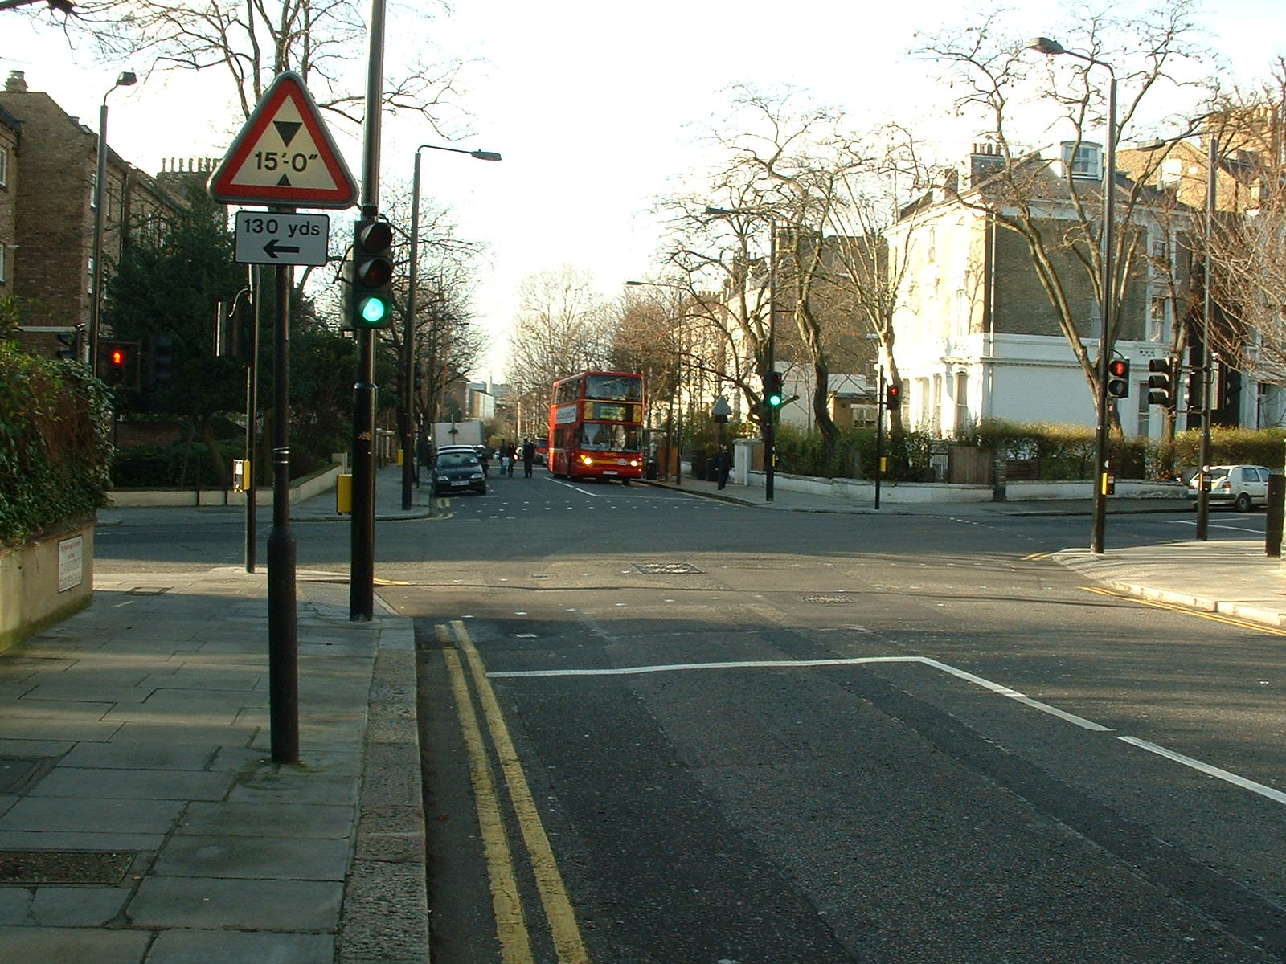

3.2.2 At least one secondary signal shall be provided on each approach so that the signal is visible from the centre of the associated stop line. It should be sited within an arc of 30° to the offside from the centre of the stop line.

3.2.3 Secondary signals typically have the same information as the primary and may have additional information, which must not conflict with that shown on the primary signal. An example is a right turn indicative arrow which in Regulation 33 (4) and TAL1/06, is considered as an additional aspect.

3.2.4 The secondary signal should be sited no further than 50m from its relative stop line.

3.2.5 Closely associated signals (CASS) should be considered early in the design stage process as the correct use can lead to a reduction in the right turning traffic collisions (London Accident Analysis Unit Report ATWP25 and ATWP37).

3.2.6 CASS should always be installed on the approach opposite to the one with a right turn overlap facility unless the approach opposite to the one with a right turn overlap has a prohibited right turn Traffic Regulation Order in place, and is signed with the appropriate regulatory box sign, far-sided secondary signal can be installed.

3.2.7 Where possible, consideration should be given to the reduction of street furniture. Examples of good practice include mounting signals on lamp columns, designing out internal stop lines requiring additional street furniture, placing multiple signals on a single pole.

3.2.8 The layout of green arrows on signal heads shall be in accordance with TSRGD 2002.

3.2.9 Each traffic lane shall have a clear vision of at least one primary signal associated with its particular movement. The Desirable Minimum Stopping Sight Distance (DMSSD) is defined in TD 50/04 and calculated using Table 3 in TD 9/93.

|  |  |  |
| --- | --- | --- |
| 85th percentile speed (mph) | 85th percentile speed (kph) | Visibility distance of signals |
| 31 | 50 | 70 |
| 37 | 60 | 90 |
| 44 | 70 | 120 |
| 53 | 85 | 160 |
| 62 | 100 | 215 |
| 75 | 120 | 295 |

3.2.10 The traffic signals warning sign (TSRGD2002, Diagram 543) should be used if the visibility distance is less than this and should always be used where the 85th percentile speed exceeds 50mph (80kph) (Traffic Signs Manual Chapter 4, Section 8).

3.2.11 The measurement shall also take into account the vertical traffic signal alignment. See figure 2/1

Source: TD50/04 Figure 2/1

3.2.12 Due to historical highway layout it may not be possible to achieve the full DMSSD. Where the approach does not meet the DMSSD, the Designer shall identify the available stopping sight distance and propose the most appropriate signals layout, to maximise the available visibility distance.

### 3.3 Inter-visibility Envelope (new Junctions)

3.3.1 Designs of new signalised junctions should follow the junction inter-visibility zone guidelines outlined in Chapter 2 of TD 50/04. Major obstructions to inter-visibility should be avoided.

3.3.2 The junction inter-visibility zone is defined as the area bounded by measurements from a distance of 2.5m behind the stop-line extending across the full carriageway width for each arm. If an Advance Stop-Line is provided the inter-visibility zone is measured from a point 2.5m behind the cyclists’ stop-line. This is because the cycle reservoir behind the Advance Stop-Line does not create any physical impediment to inter-visibility.



Source: TD50/04 Figure2/2

### 3.4 Swept Paths Analysis

3.4.1 Adequate turning radii shall be provided for the swept paths of all classes of vehicle using the junction. For new junctions, and geometric modifications of existing junctions, the initial design should include proof that movements can be made by all classes of vehicles that are expected to use the junction (TD 50/04 Chapter 2, TD 42/95).

3.4.2 Swept paths output shall demonstrate a safe waiting area, where turning vehicles do not overrun:

* 1. Conflicting traffic movements, such as stop-lines and centre lines
  2. Pedestrian / cyclists waiting areas
  3. Separation islands
  4. Kerb lines

3.4.3 The swept paths should also take into account any issues with clearances to Street furniture, including all traffic signal equipment.

NB: For sites with an advance cycle stop line and lead-in cycle lane, the width of carriageway should be taken from the outer edge of the cycle feeder lane and not from the kerb edge when undertaking swept paths analysis.

### 3.5 Clearance

3.5.1 A minimum horizontal clearance of 450mm must be provided between the edge of the carriageway and any street furniture (TD 50/04 Chapter 4). Additional clearance may be required if the crossfall of the carriageway is greater than 2.5%, at roundabouts or at high speed sites where the equipment is not protected behind safety fencing. At these locations a clearance distance of 600mm is a suggested value but could be increased if the setback does not impede pedestrian routes.

3.5.2 All signal heads must be installed with a minimum vertical clearance of 2100mm (TSRGD 2002 Schedule 8) or 2300mm, above a cycle track / shared footway (Traffic Signs Manual Chapter 3, Section 1). A signal head may be mounted at a maximum height of 6.1m measured to the centre of the amber aspect if the character or layout of the road affects the visibility of the signals (TAL 1/12).

3.5.3 Diagrams of signal installations with their dimensions and clearances are given in Appendix A.

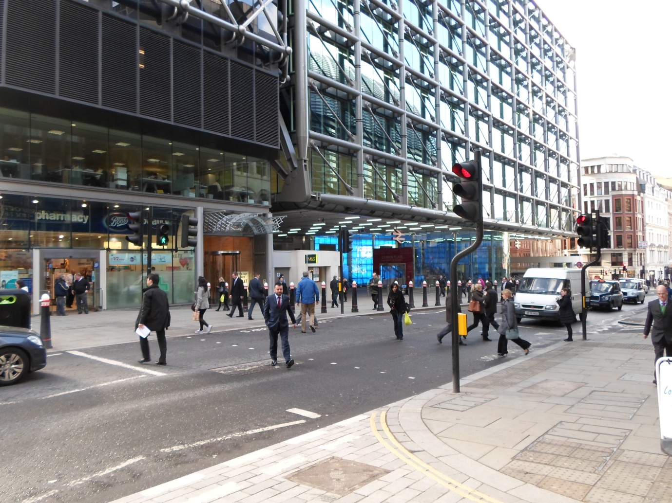

Illustration - Pole installed close to kerb line to avoid utility services

To achieve the necessary 450mm clearance to the signal head a cranked pole was installed.

### 3.6 Lane Widths

3.6.1 Entry Lane widths should be between 3.0m and 3.65m, unless there are specific reasons for wider or narrower lanes.

3.6.2 If there are a significant number of cyclists a minimum of 4.0m should be provided. A minimum of 2.5m for a straight ahead lane is acceptable in some cases, and in exceptional circumstances lanes could be reduced to 2.25m if provision of large goods vehicles is not required. A dedicated turning lane is recommended to be a minimum of 3.0m wide.

3.6.3 Consideration should be given to the safety of cyclists when narrow lanes are proposed (TD 50/04 Chapter 2).

### 3.7 Cycle Lanes

3.7.1 Cycle lanes should be a minimum of 1.5m wide (recommended value is 2m), although they can be slightly narrower over short lengths.

3.7.2 Mandatory cycle lanes, bounded by a solid white line require a Traffic Regulation Order. Advisory cycle lanes, bounded by a broken white line, can only be used by other vehicles if safe to do so. Cyclists are normally permitted to use a with-flow bus lane, so a separate cycle lane is not required on an approach (Traffic Signs Manual Chapter 5 Section 16, TD 50/04 Chapter 4).

### 3.8 Bus Lanes

3.8.1 Bus lanes should be a minimum of 3.0m wide. However a width of 4.5m is recommended as this allows a bus to overtake a cyclist without leaving the lane. (LTN 1/97, LTN 2/08)

3.9 Road Markings

3.9.1 Carriageway markings are specified in TSRGD 2002 schedule 6 and the Traffic Signs Manual Chapter 5.

### 3.10 Stop Lines

3.10.1 The stop line must be a minimum of 200mm wide (300mm wide where the 85th percentile speed of the road is over 35mph) and should be positioned at right angles to the centre line of the carriageway. It should be at least 1.5m from the nearside primary signal but preferably 2.5m (TSRGD 2002 Schedule 6, Traffic Signs Manual Chapter 5, Section 9).

3.10.2 The nearest line of crossing studs should be positioned 0.5m from the nearside primary signal.

### 3.11 Advance Cycle Stop Lines

3.11.1 Advance Cycle Stop Lines (ASLs) may be placed at signal controlled junctions (TSRGD 2002 Direction 18(2)) and are recommended at all junctions on the TLRN. They are not permitted at standalone crossings.

Source: TSRGD 2002, Diagram 1001.2

3.11.2 The recommended length of the reservoir is 5.0m (4.0m is the minimum length), extending across all traffic lanes. ASL’s up to 7.5m depth have been approved by the DfT, but part width ASL still require DfT authorisation.

3.11.3 The recommended distance between the advanced stop line to the studs is between a minimum of 1.7m to a maximum of 3.0m.

3.11.4 A lead-in lane to the ASLs is recommended, with a minimum width of 1.5m, but where this is not possible due to space constraints there can be a narrow diagonal broken line which cyclists may cross to enter the priority reservoir (TAL 1/12).

3.11.5 The approach cycle lane should normally be located on the nearside of the carriageway, but if there is a significant left flow of motor vehicles but cyclists travel straight ahead, an advisory lane could be positioned centrally. For more details, see London Cycling Design Standards report.

3.11.6 Other factors that should also be taken into account during the design include:

1. Intergreens, should always be calculated for the worst case scenario, considering both the vehicle and cycle stop-lines, from the furthest to the nearest point (TSRGD, Regulation 43).
2. An appropriate method of detection for cyclists.
3. At existing sites where ASL’s are being installed, it may be necessary to relocate the existing stop line detection or replace with overhead detection and consider the relocation of any red light cameras.

NB: Intergreens for cycle only movements should take into account the lower speed of cyclists and hence the longer time taken to clear the conflict point.

### 3.12 Safety Cycle Mirrors

3.12.1 On 17 February 2012, the DfT gave UK wide approval to use 300-500mm diameter mirrors for the purpose of improving road safety for cyclists.

3.12.2 In London, 500mm blind spot safety mirrors have been installed on primary traffic signal poles to improve the visibility of cyclists that have entered a large good vehicle driver’s near side blind spot. The mirrors have been installed at key junctions, primarily on the Barclays Cycle Superhighway routes. Technical details can be found in TfL Safety Cycle Mirror Installation Method document.

### 3.13 Zig-Zags

3.13.1 Zigzag markings must only be used at stand-alone crossings. They cannot be used at junctions or on exit streams (Traffic Signs Manual, Chapter 5, Section 15).

3.13.2 No other road markings are permitted within the zigzag area.

Source: TSRGD 2002, Diagram 1001.3

### 3.14 Yellow Boxes

3.14.1 Yellow box markings may be used at signal controlled junctions or roundabouts where traffic is controlled by signals at all times (TSRGD 2002 Schedule 6, Traffic Signs Manual Chapter 5, Section 12). However it is recommended that consideration is given to using advisory “Keep Clear” markings where legal enforcement is not necessary (TfL Streetscape Guidance 2009).

### 3.15 Elephant’s Footprints (markings to WBM294)

3.15.1 The marking known as “Elephant’s Footprints” may be used for a cycle crossing at a signalised junction but requires DfT authorisation (LTN 1/86, TA 91/05).

3.15.2 New road markings are being considered by the DfT to emphasise the cycle lane and indicate the desired/correct route across a junction (Traffic Signs Policy Paper, Signing the Way, October 2011).

### 3.16 Coloured Surfacing

3.16.1 In London, the following coloured surfacing is in use:

1. Red - Bus Lane or pedestrian crossing zone (installed between crossing studs)
2. Green - Cycle lane or ASL area
3. Blue - Cycle lane or ASL area on a Cycle Superhighway

3.16.2 Some local Highway Authorities have different policies on the use of colour surfacing and some, notably Westminster City Council do not permit any coloured surfacing.

NB: Coloured surfacing is not prescribed in TSRGD 2002 and has no legal significance.

### 3.17 High Friction Surfacing

3.17.1 All new installations on the TLRN shall have a minimum length of 50m of skid resistant high friction surfacing applied ahead of the stop line on all approaches. The skid resistant surface should extend to the first row of studs. On a gradient, or on roads with a speed limit greater than 30 mph, it may be necessary to increase the length of skid resistant surface beyond the 50m length. Consideration should also be given to extending the surface to the centre of the junction as this will help to reduce cross road and right turning collisions (TD 50/04 Chapter 2).

3.17.2 For further information regarding the requirements of high friction surface that is appropriate to be installed, see HD28/04 (DMRB 7.3.1). The installed road surface shall meet the minimum Polished Stone Value (PSV), which is a measure of the resistance of an aggregate to the polishing action of a pneumatic tyre under conditions similar to those occurring on the surface of a road.

### 3.18 Traffic Islands/Refuges

3.18.2 Where a pedestrian crossing phase is timed to permit pedestrians to cross a whole carriageway in one movement, then the width of a refuge in the carriageway shall be a minimum of 1.5m (TD 50/04 Chapter 4). However, a width of 2.0m is recommended to permit a pedestrian with a pram or wheelchair to wait in safety. (LTN 2/95, Inclusive Mobility)

3.18.3 Islands that are not used by pedestrians can be reduced to 1.3m wide for a simple 3 aspect signal head or 1.7m if the signal head has a side mounted arrow or box sign.

3.18.4 Where there is a staggered pedestrian facility the island should be a minimum of 3m wide. This can be reduced to 2.5m if guard railing is not provided on the central island.

3.18.5 Where there is a staggered facility catering for shared-use (i.e. Toucan crossings), the island should be a minimum of 4.0m wide. This can be reduced to 3.5m wide if guard railing is not provided on the central island.

3.18.6 With a staggered pedestrian facility the minimum recommended distance between crossings (i.e. the distance between the inside line of studs on each side of the island) is 4m. To reduce “see through” issues, louvred hoods should be considered on the far-sided green figure aspects.

3.18.7 At locations where the central island is very wide, in excess of 7m, the stagger can be eliminated. In this scenario, louvred hoods should be fitted to the far-sided green figure aspects.

### 3.19 Crossing Width

3.19.1 The minimum width of a pedestrian crossing is 2.4m. The recommended width of a toucan crossing is 4.0m, but absolute minimum is 3.0m. The maximum width of a crossing (from stud to stud lines) is 10.0m, usually dependent on the number of pedestrians expected to use it (TSRGD 2002 Schedule 6, TD 50/04 Chapter 4).

3.19.2 The preferred orientation of the staggered crossing is such that pedestrians in the central reserve are facing oncoming traffic as they approach the crossing, but this may not always be possible (TD 50/04, Chapter 4).

### 3.20 Footway Width

3.20.1 It is recommended that a footway has a clear width of at least 2000mm (this allows two wheelchairs or pushchairs to pass one another comfortably). If there is an obstacle, the absolute minimum clear width should be 1000mm for a maximum length of 6m (Inclusive Mobility section 3).

### 3.21 Tactile Paving

3.21.1 Tactile surfaces and dropped kerbs shall be provided where pedestrians are expected to cross an arm of a junction. Tactile paving should be laid in an “L” shaped pattern on the extremities of the crossing points with the upright of the “L” aligned in the direction of the crossing. Tactile paving is not recommended on a pedestrian refuge (TD 50/04 chapter 4).

3.21.2 However, the installation of tactile surfaces is the responsibility of the highway authority who may have their own local policies, examples include not using a “tail” in the L shaped pattern and matching the colour of tactile paving to the surrounding finish. Further information can be found in the DfT document Guidance on the Use of Tactile Paving Surfaces (DETR 1998).

4 Signalised Pedestrian Facilities At Junctions

(See TAL 5/05, LTN 2/95, TD50/04 and TA68)

4.1 General

4.1.1 Where signalised pedestrian facilities are being provided, audible and/or tactile devices must be provided for the visually impaired in addition to the normal Red and Green Man. Tactile and audible devices should always operate at the same time as and be interlocked with the Green Man indication. Red Lamp Monitoring must be provided to monitor any vehicle phase that conflicts with a pedestrian phase.

4.1.2 The location of the signal equipment is stated in LTN1/98 ‘The installation of Traffic Signals and Associated Equipment’, but the Designer must assess site conditions before determining the final layout. The TI Engineer shall be responsible for deciding whether far sided, nearside or countdown signals are suitable for use.

### 4.2 Farside

4.2.1 Farside is the standard type of pedestrian facility to be installed at junctions across London and can be used in conjunction with countdown.

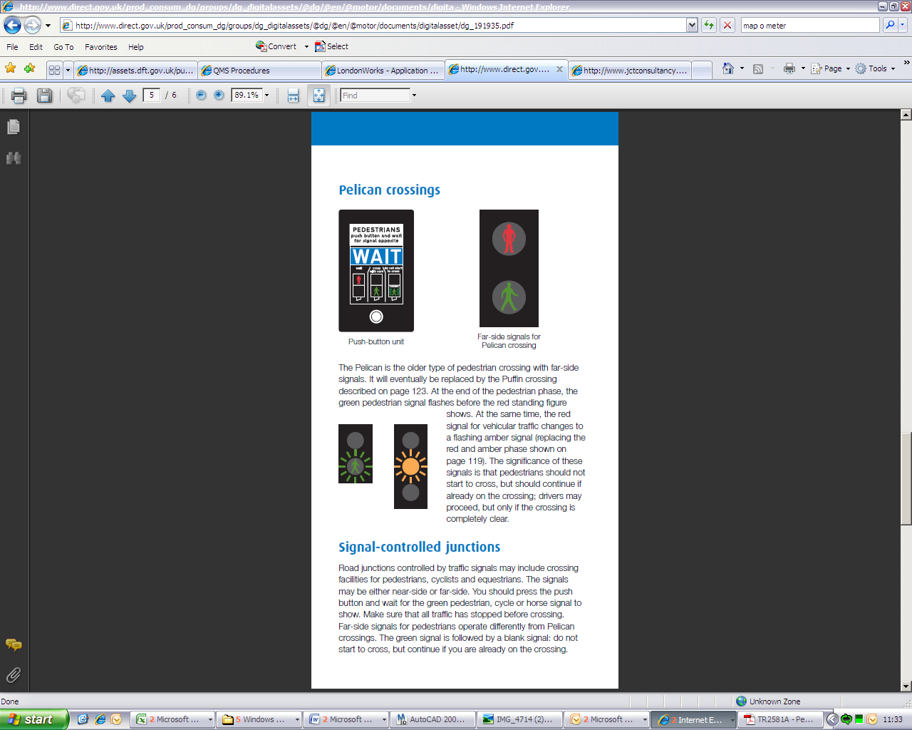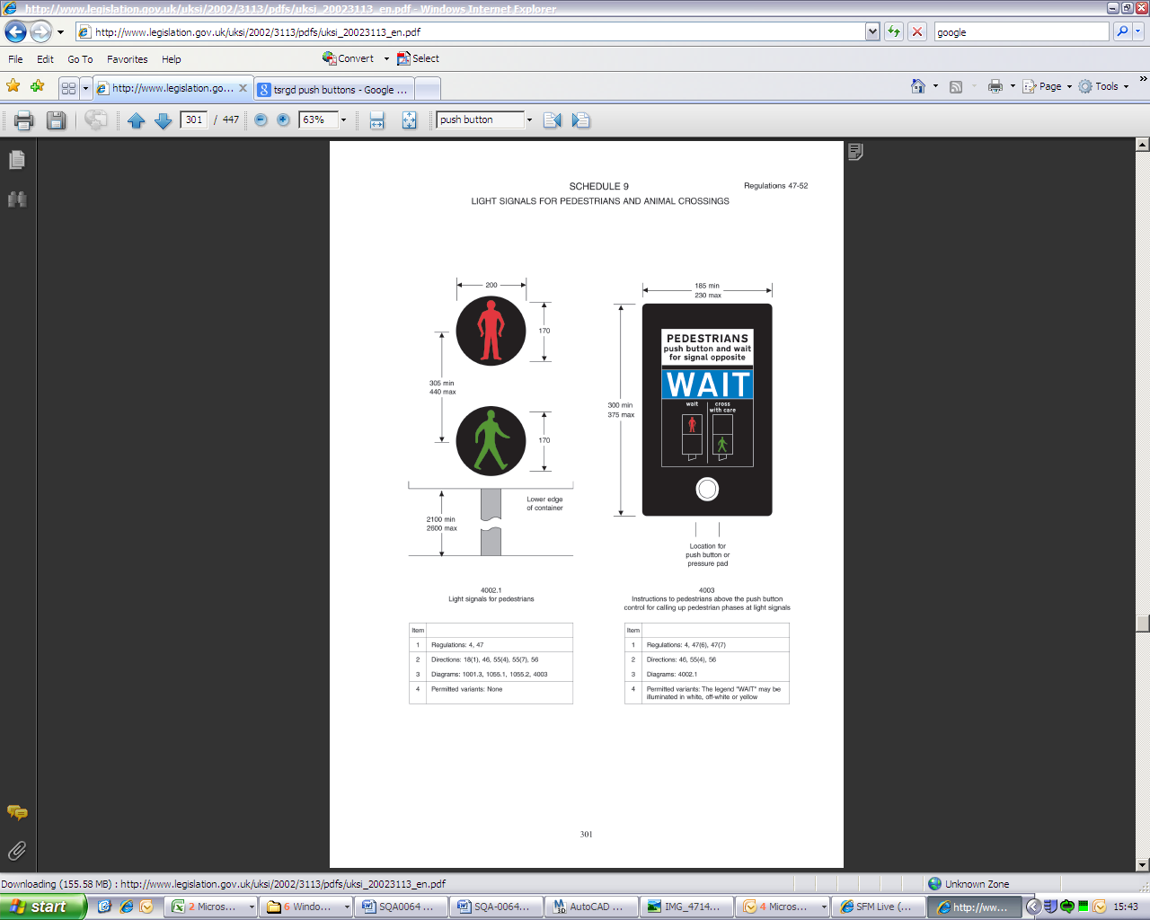

4.3 Nearside

4.3.1 Nearside facilities can be installed but it is recommended that this is only used if in an area where other puffin crossing facilities are installed to reduce pedestrian confusion.

### 4.4 Pedestrian Countdown

4.4.1 Pedestrian Countdown is also known as Pedestrian Countdown at Traffic Signals (PCaTS) provides additional information to pedestrians during the blackout period. The PCaTS timer improves pedestrian understanding that the Green Man is only an invitation to cross and is followed by a safe clearance period. Further design details can be found in the GN46 – The Pedestrian Countdown design guidance document.

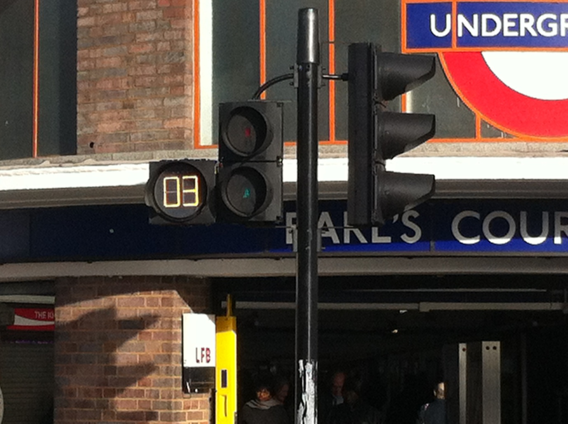

### 4.5 Push Buttons

4.5.1 In the majority of cases push buttons should be located to encourage pedestrians to look towards the nearest flow of oncoming vehicles, although this may not be possible depending on the layout of the site. The Designer may wish to provide additional demand units if site conditions make this desirable.

4.5.2 Where audible and/or tactile devices are provided for parallel crossings without the protection of a stop line, ‘All Red’ extending detectors may be desirable to inhibit the pedestrian signal while vehicles are still on the crossing. If ‘All Red’ detectors are used in a CLF or in UTC care must be taken in arranging the group timings in order to prevent stage skipping.

4.5.3 Pedestrian push button units associated with far side signals should normally be mounted at an angle of 45° to the kerb line with the base of the unit 1.0m from the surface of the footway. Where near side signals are used they should generally be mounted at an angle of 25-30° to the kerb line.

### 4.6 Centre Islands

4.6.1 Where central refuges are provided there should ideally be two push buttons installed, of which both should be fitted with tactile units (TAL 5/05 Part 3). Tactile paving should not be provided in centre islands.

### 4.7 Detection

4.7.1 The use of on-crossing and kerbside pedestrian detection at junction installations is only permitted at near side installations. (TR2507A)

### 4.8 Timings

4.8.1 Pedestrian crossing timings are covered in SQA 645. Traffic Signal Timings.

5 Signalised Cycle Facilities at Junctions

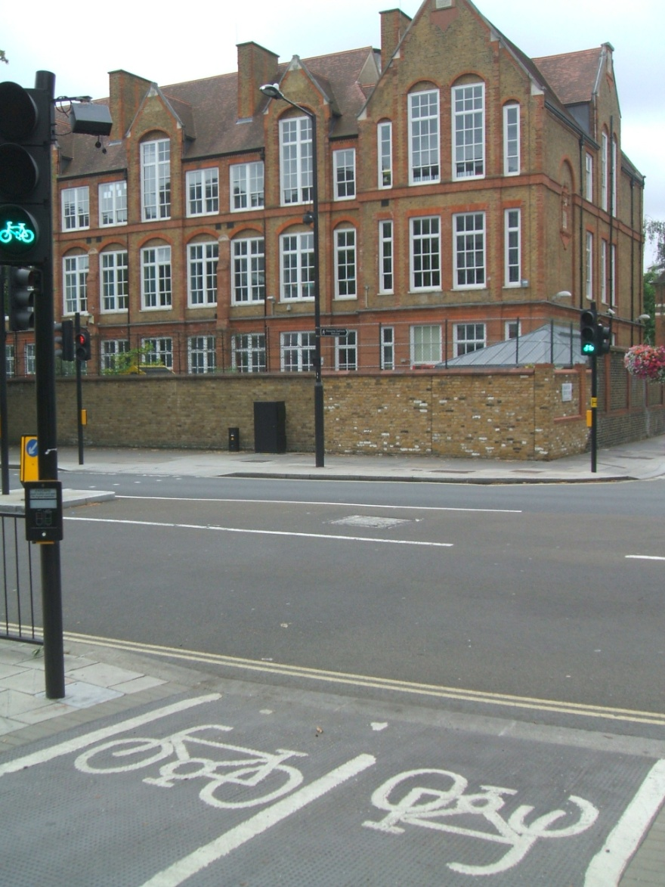

5.1 General

5.1.1 Where safety considerations, traffic flow, speed or demand provide justification, signal controlled cycle facilities can be used to enable cyclists to cross roads. Cycle facilities can come in the form of a toucan, or parallel cycle/pedestrian facilities.

### 

5.2 Parallel cycle and pedestrian crossings

5.2.1 Such layouts should be adopted where there is a high demand by cyclists and/or pedestrians, the segregation helps reduce potential conflicts on the crossing. They are also useful where the cyclists approach from a different direction to the pedestrians.

5.2.2 If a route through a signalised junction is specifically for cyclists, it may be appropriate to provide “Elephants’ feet” markings, although these should only be considered where the cyclists route may not be obvious. Currently “Elephants’ feet” require DfT approval (TA91/05 6.14 & LTN 1/86).

5.2.3 As at other facilities there should be at least 2 signals visible from each approach when pedestrian facilities are provided for red lamp monitoring purposes, however this can be reduced to a single signal head if this is not the case.

5.2.4 If a pushbutton unit is provided to activate cyclist signals, DfT authorisation is required.

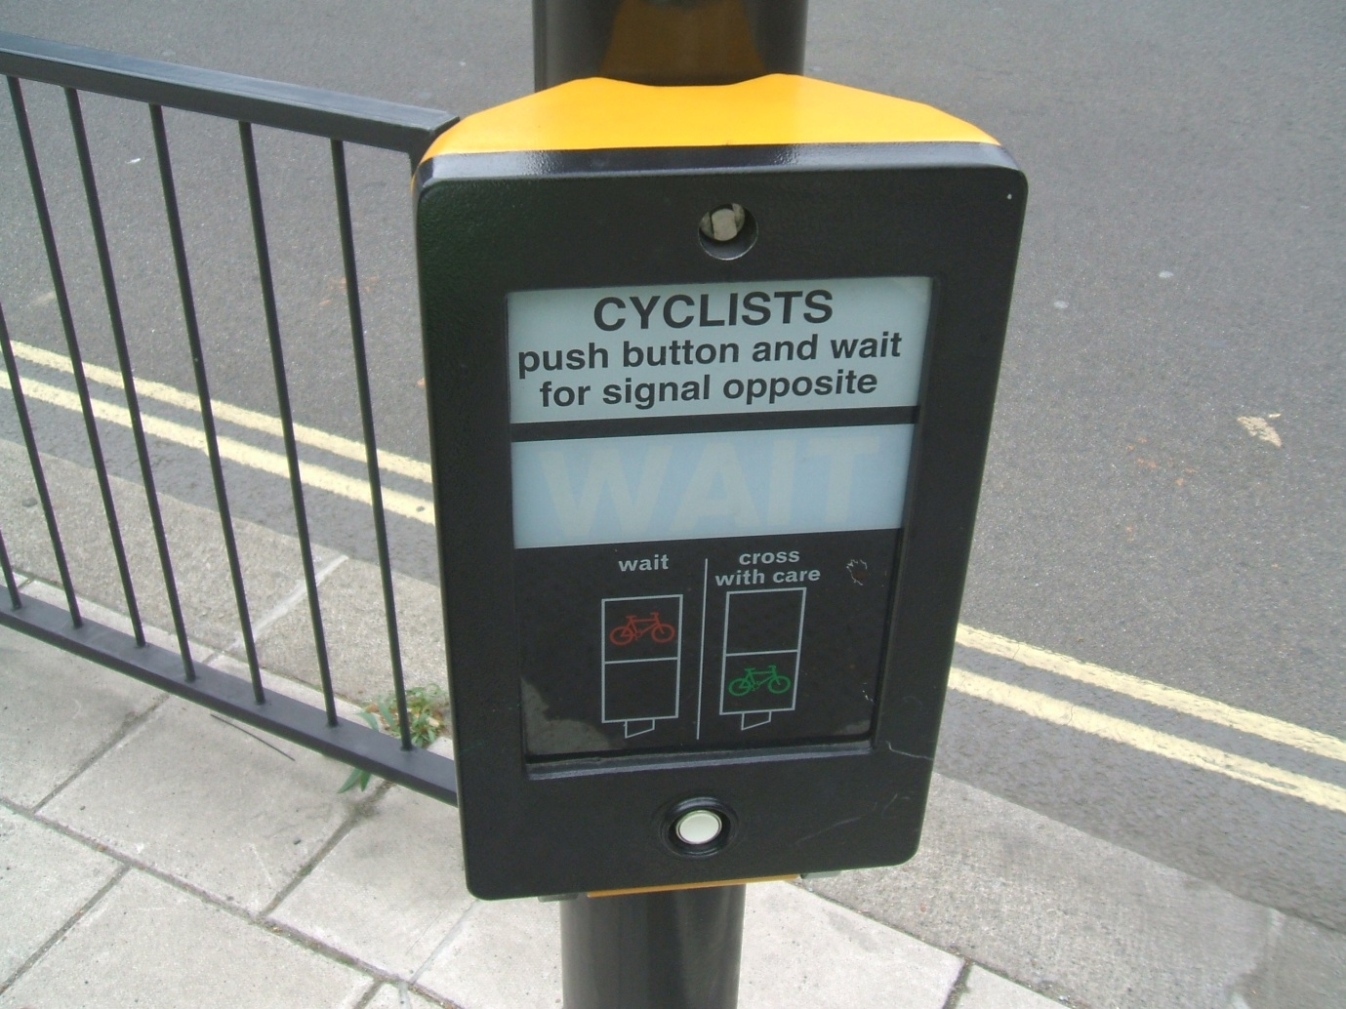

5.3 Toucan facilities

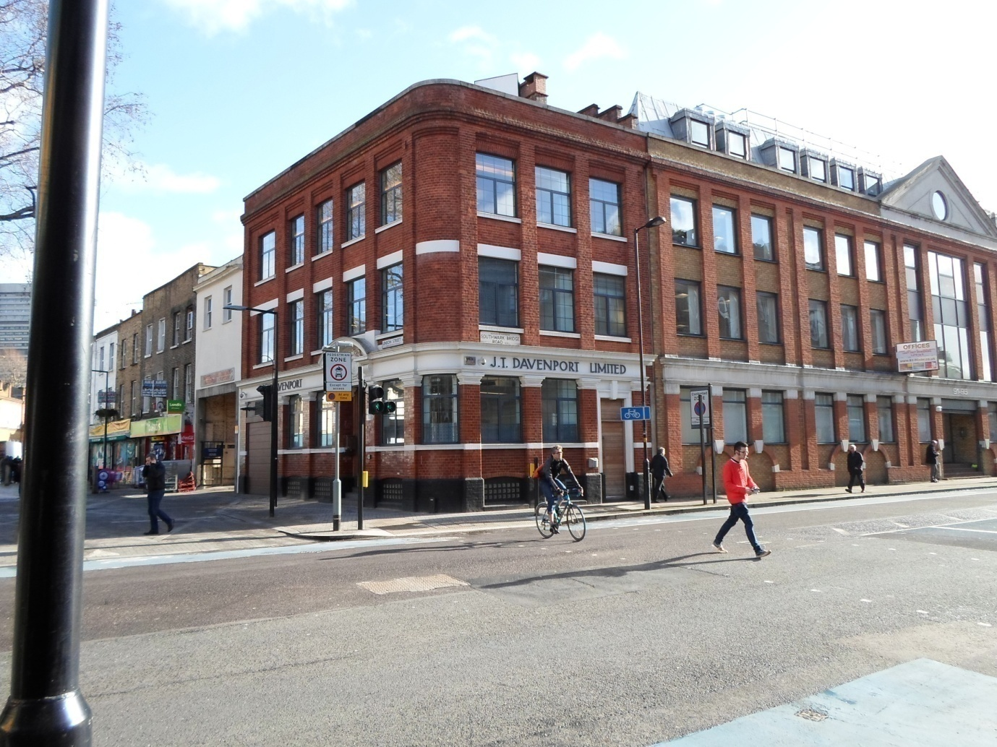

5.3.1 Toucan facilities should be considered when the flow of pedestrians and cyclists is lower and they are able to share the same area. Footway segregation is created by a feature such as a white line, unless it is a designated shared route, in which case pedestrians and cyclists can mix freely and share the full width of footway. Further guidance is given in LTN 2/08 Cycle Infrastructure Design.

### 5.3.2 Farside

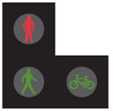

### Farside is the preferred type of toucan facility installed at junctions across London.

5.3.3 Nearside

**

Nearside facilities can be installed at junctions, but it is recommended that this is only used in an area where other nearside toucan crossing facilities are present.

5.3.4 Toucan facilities should be installed to a minimum width of 4 metres, reducing the feeling of overcrowding. Depending on the volume of cyclists and pedestrians this may be reduced to 3 meters or increased to a maximum width of 10 meters.

5.3.5 At toucan facilities, the Designer shall consider the provision of audible and tactile devices, dropped kerbs and tactile paving.

5.3.6 The push buttons may need to be located so that the wheel of cyclists does not protrude into the carriageway.

### 5.3.7 Detection

Where nearside pushbutton units are installed, the use of kerbside and on-crossing detection is optional. These are not required at farsided signals.

### 5.3.8 Timings

Pedestrian crossing timings are explained in SQA-0645

6 Equestrian Facilities at Junctions

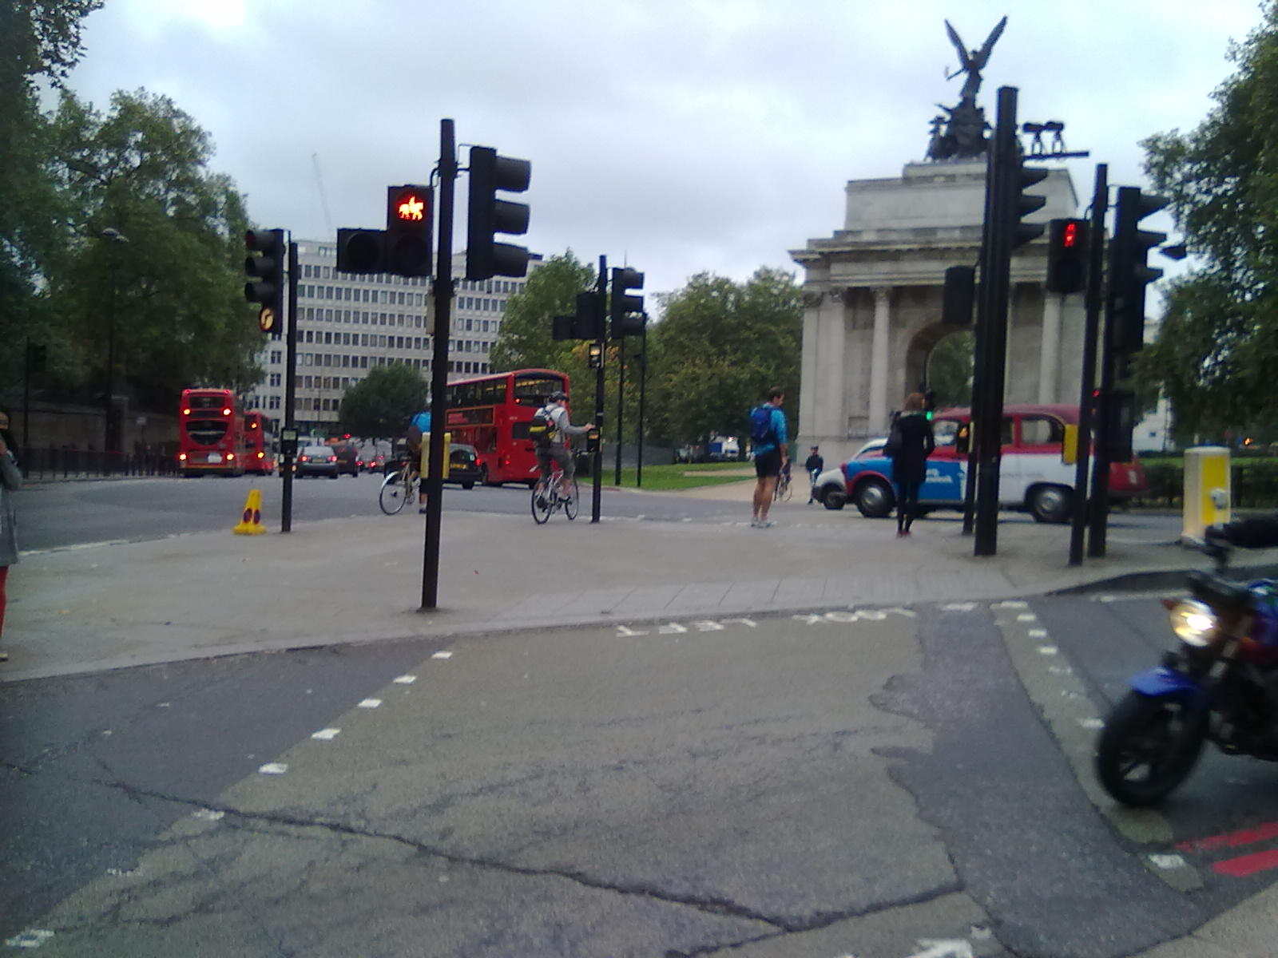

### 6.1 Special authorisation

### 6.1.1 Special authorisation is currently required for signal controlled crossings incorporating equestrian facilities (TD50/04). Additional information on provision for equestrians is contained in TA 57/87 and TA 68/96.

6.1.2 Where specific measures are being considered for equestrians it is important for Designers to recognise that the reaction of horses is not predictable, which can make control difficult for the rider. Designers should consider the effect of such behaviour and other road users when providing specific measures for equestrians. The following measures should be considered:

1. Increase eye height to 2.7m when considering visibility requirements for riders
2. Avoid situating crossing points in soft verges which contain dangerous items such as manholes, gullies and ditches
3. Ensure that there is sufficient verge width to accommodate the horse(s)
4. Avoid excessive use of large road markings on the carriageway or crossing, which can disturb horses
5. Avoid locating crossings where sudden noises are likely to occur
6. Push button units should be installed at 2.0m height for mounted equestrians with additional units at standard height for the dismounted rider leading the horse
7. Staggered crossings are not advised for equestrians
8. Timings should take into account the special needs of equestrians and the additional intergreen period
9. segregation of equestrians from pedestrians and cyclists.

(Source: TA90/05)

6.1.3 Figure below illustrates an example of a segregated pedestrian/equestrian crossing where a bridleway approaches and crosses a single carriageway.

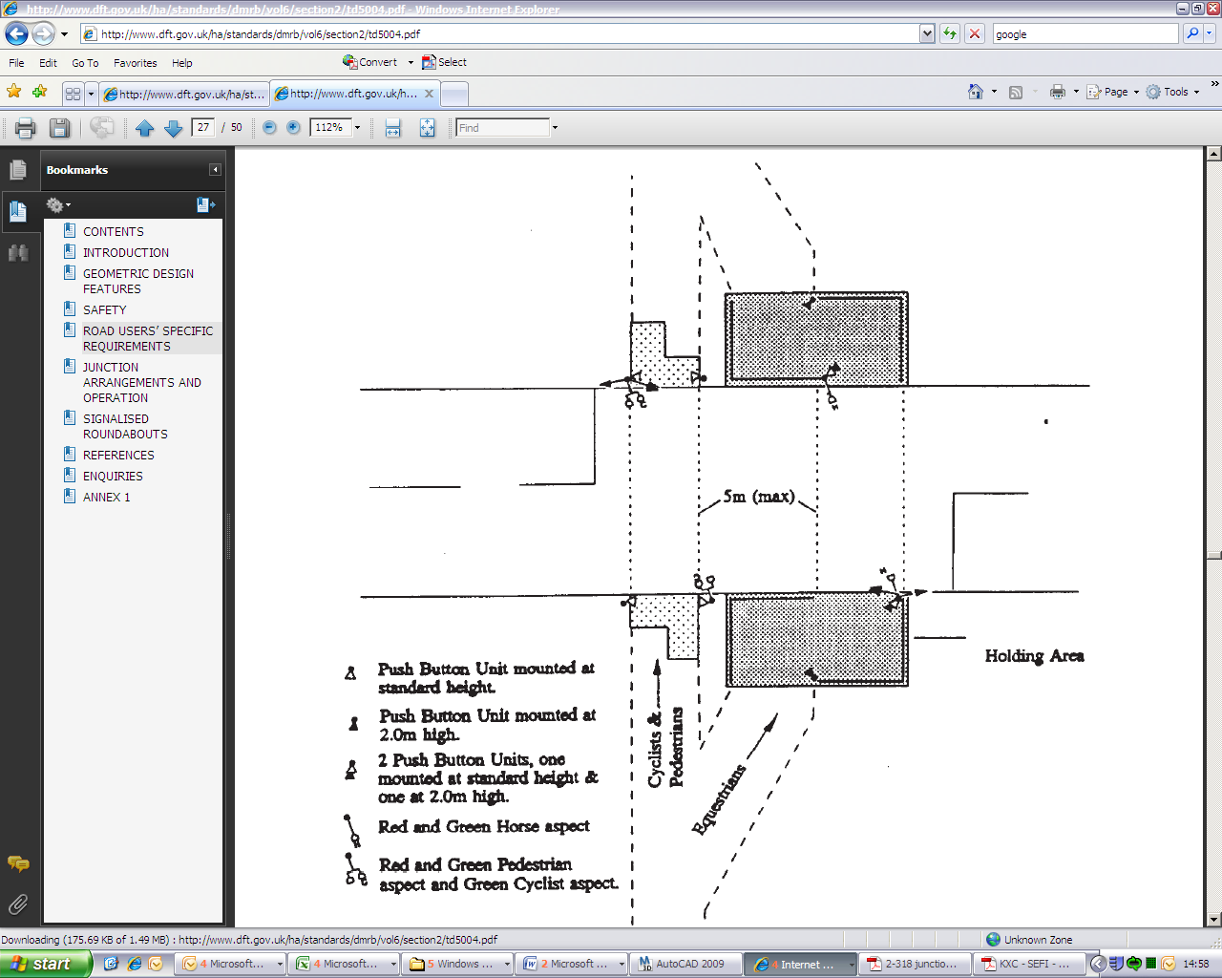Source: TD50/04 Figure 4/4

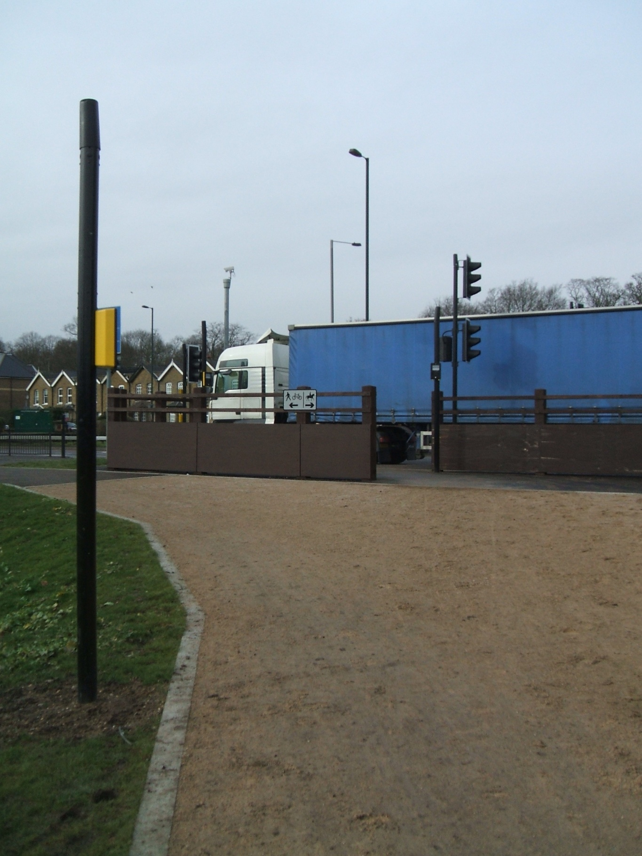

Equestrian facility as installed across Roehampton Vale

6.1.4 TA 68 does not encourage the use of central refuges on single carriageway roads; however where a signalled equestrian crossing is being provided the use of central islands with a single stage crossing may be considered appropriate, to:

1. focus drivers’ attention on the crossing;
2. prevent overtaking;
3. act as a speed reduction measure.

6.1.5 TA 57/87 recommends that uncontrolled at-grade equestrian crossings of dual carriageways are not provided. When determining the requirements for bridleways, Designers should consider diversions to avoid the need to cross the dual carriageway at-grade. Where diversions cannot be provided, Designers should consult with the highway authority and local equestrian groups.

6.1.6 Consideration during the design process should be given to the fact that although an equestrian facility has been chosen as the appropriate crossing facility it may not solely be used by horse and rider alone and other users should be considered.

### 6.2 Highway Layout

6.2.1 Equestrian facilities should only be provided where ridden horses are to be accommodated, usually where a bridleway crosses a major route.

6.2.2 It is a common practice to provide a cyclist and/or pedestrian as well as an equestrian crossing facility. Where this is the case the pedestrian/cyclist and equestrian parts of the crossing must be segregated as outlined in TSRGD Schedule 6. A minimum of 3 metres is recommended between the two parts. The prescribed maximum is 5 metres in order to deter drivers from stopping between the two crossings.

6.2.3 Direction on an appropriate layout and materials for holding areas can be found in TA90/05 and TAL3/03.

### 6.3 Push Buttons

6.3.1 As a rider of a horse can be 1.8m from the nose of the horse, it is crucial that any push button is sited sufficiently far enough back from the carriageway edge. It is thought that a minimum of 2 metres is a reasonable minimum distance but depending on the speed of the road and size of vehicles that use the road the Designer should amend this according.

6.3.2 High level repeater units should be mounted at height above ground level, 1.5m to 2m range is recommended. Additional push button units can be located some distance from the junction, for example to insert early demand, or hurry call to a specific stage.

### 6.4 Legend

6.4.1 Both far side and near sided equestrian crossing facilities are acceptable although at junctions far sided equipment is recommended.

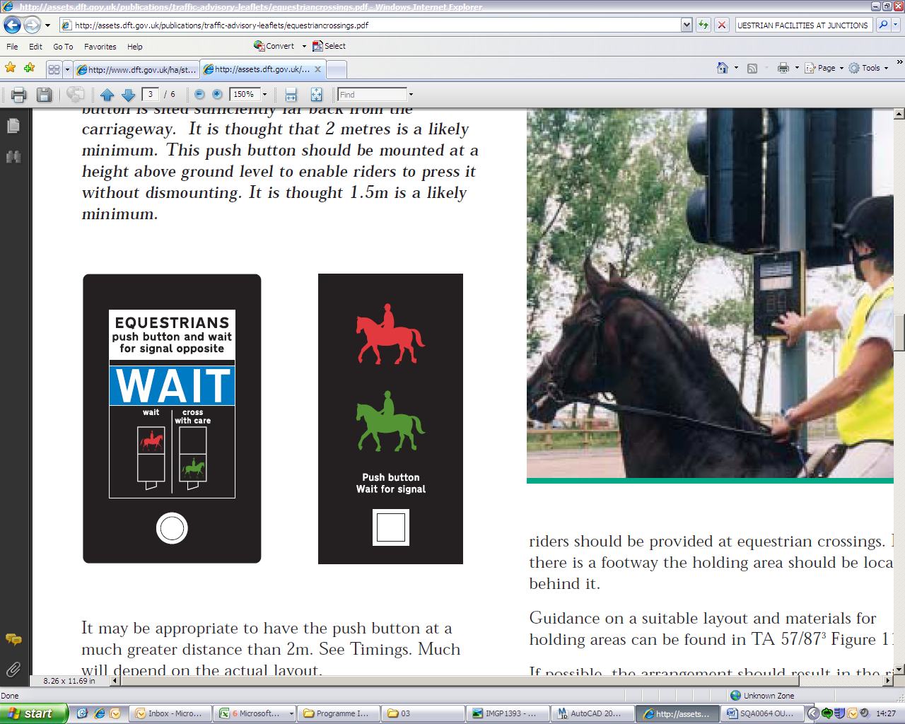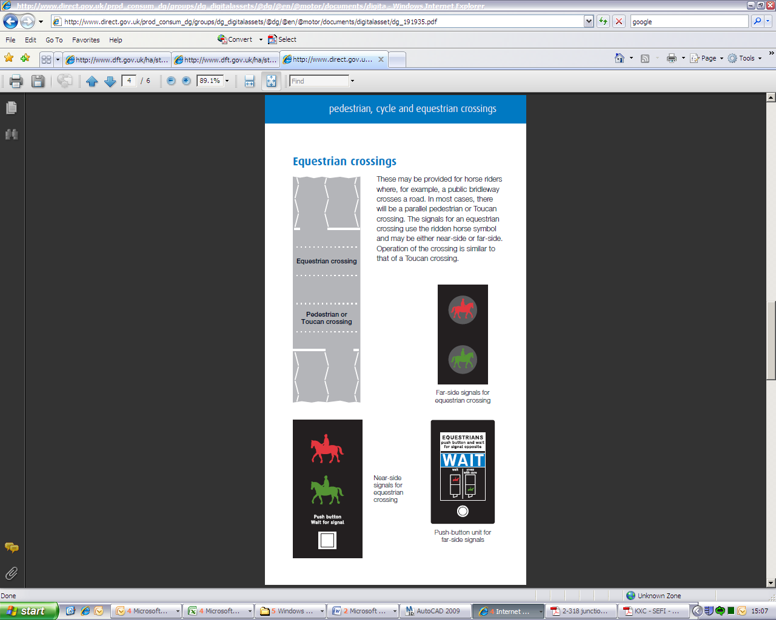

Farside Signal Equipment

NEARSIDE SIGNAL EQUIPMENT

(Which can be used in conjunction with single demand unit)

### 6.5 Timings

6.5.1 The timings for Equestrian Crossings are based on those for Toucan Crossings.

6.5.2 Equestrian crossing timings are explained in SQA-0645.

7 Equipment

### 7.1 Signal Poles

The following traffic signal pole variations are available to the Designer:

1. 4m standard pole –

This is the most common traffic signal pole used in London.

1. 2m short pole –

Used to mount push button unit only.

1. Formed 4m pole –

Used to overcome design limitations, examples include substandard footway, existing services at proposed signal post location, unfavourable road curvature.

1. 4.25m pole –

Used in conjunction with formed 4m pole, to match the height of the amber signal.

1. 4.85m pole –

Used to help achieve the required signal visibility.

1. 6m pole –

Used to install elevated signal, to further improve signals visibility. Duplicate primary signals are recommended on all high speed approaches (TAL 12/07).

Designer should consider using retention sockets and allow for 1200x1200mm foundation footprint.

1. Mast arms –

Not specified in London due to maintenance difficulties and lack of foundation space. However if they are provided, they must be installed with a minimum clearance of 5.5m from the carriageway (TR2206 appendix E).

1. Removable pole –

Used in locations where special events require the removal of traffic signals equipment.

1. Plated pole –

In situations where it is not possible to achieve the required installation depth, a custom made plated pole can be specified.

7.1.1 If a plate is fitted to the foot of the pole, the minimum dimension must be not less than 0.3m in length for each side (TR2206A Appendix E).

Further information about the installation of traffic signal equipment can be found in TCSU8 Specification for the Installation of Traffic Signals and Associated Equipment.

7.1.2 In order to install and maintain 4.85m and 6m poles a HIAB fitted vehicle is required. This has initial and ongoing cost implications which should be considered during the design stage.

NB: A 4m standard pole fitted with additional bracketry is the preferred option to 4m formed pole solution.

### 7.2 Signal Brackets

7.2.1 If there are footway width restrictions, a signal pole may need to be installed 500mm from the kerb, which would not allow sufficient clearance for the signal head. In this instance the signal head can be side mounted, or installed on a D bracket to achieve the required clearance. Similarly, if the signal pole is installed at the rear of a narrow footway the use of a D bracket will bring the signal head closer to the kerb and therefore make it more visible.

7.2.2 800mm and 250mm D brackets are available. A pedestrian signal head is commonly installed within an 800mm D bracket where this is installed on a pole together with a primary and secondary traffic signal head (see DWG GEN/TTS_6/SIGDIM3A), the 800mm D bracket has enough space for a Toucan aspect or a Countdown unit.

7.2.3 250mm D brackets are commonly used at sites with nearside pedestrian facilities to give extra room for the installation of the above ground detectors.

7.2.4 Above ground detectors are commonly supplied with spacer brackets which allows them to be installed above the signal heads or backing boards. Also, a 4-in-line bracket can be used in situations where high sided vehicles strike side mounted detectors.

### 7.3 Hoods And Louvres (TR2206A, Section 3)

7.3.1 Hoods shall be fitted to traffic signal aspects. The Designer may consider the use of special hoods to avoid “see through” problems. Available permutations include louvred (vertical or horizontal), long and long cutaway hoods. Louvred hoods should never be used on red aspects.

7.3.2 Typically, vertical louvred hoods are fitted to farsided green pedestrian aspects and horizontal louvred hoods are used to mask traffic green and amber aspects. Designer may consider mixing vertical and horizontal alignments, for example, to improve visibility for turning traffic.

7.3.3 When installing special hoods, the correct alignment should be checked at commissioning.

NB: At standalone crossings, the secondary signal shall be fitted with primary hoods.

### 7.4 Backing Boards

7.4.1 Direction 46 of TSRGD 2002 allows for backing boards to be fitted to traffic signals.

7.4.2 Backing boards are normally not fitted in London except on signals on TLRN roads with speed limits greater than 30mph and on other roads where, in the designer’s judgement, there is a problem with the sun on east/west alignments, street lighting or other valid reason.

7.4.3 Backing boards should be considered if traffic signal installations on the same route are fitted with backing boards. If backing boards are required, these should be fitted to all traffic signal heads at the junction.

7.4.4 Backing boards must always be provided with outreach signals on mast arms (TR 2206A Section 3).

### 7.5 Dimming

7.5.1 Dimming facility shall be used on all installations unless specifically requested by the Highway Authority.

### 7.6 Detection

7.6.1 All vehicle detection shall comply with TR2505A Performance specification for the above ground vehicle detector systems for use at permanent traffic signals installations, and TR2512A Performance specification for below ground vehicle detection equipment.

Further guidance can be found in GN47 Above Ground Detection Units

7.6.2 Pedestrian Above Ground detection can only be installed at sites with near-sided pedestrian facilities, as specified in TR2506A for on-crossing detection systems and TR2507A for Kerbside detection systems.

7.6.3 Vehicle detection such as magnetometer sensors are considered to be a below ground solution. Further advice regarding Magnetometer sensors can be found in SQA589 “Wireless SCOOT Magnetometers: Installation and Commissioning Specification

7.6.4 Above ground detection is the preferred choice for vehicular detection for both approaching vehicles and those stationary at the stopline. The Designer should consider using two vehicle detectors per approach; an infra-red detector, as a stopline detector and a microwave detector to identify approaching traffic from 40m (TAL16/99). Additional detectors may be required on multi-lane approaches.

7.6.5 If a stopline features separately controlled movements, Designer should consider additional stopline detection, to differentiate traffic movements.

7.6.6 In order to reduce erroneous demands, the Designer should consider the use of alternative technologies, options include; image, narrow angle and unidirectional detection. It shall be possible to enhance the operation by delaying latched demands or configuring a call cancel logic.

7.6.7 The Designer should consider the extendable all-red facility where traffic flow maybe obstructed or impeded. Examples include; parked vehicles close to the junction exit, two lanes into one merge, heavy opposed right turn and an all-round pedestrian movement following the opposed right turn stage.

7.6.8 Detection on high speed approaches shall be below ground systems consisting of Speed Assessment (SA) and XYZ detectors (TAL 5/07). Speed Discrimination is not used in London.

7.6.9 For signal controlled installations, high speed is taken to mean a road where the 85th percentile approach speeds at a junction are 35mph or above.

7.6.10 Above ground detectors are not recommended to control any approach to a junction running MOVA (TAL16/99). Speed assessment equipment is not required for MOVA sites.

7.6.11 UTC SCOOT detection shall be a below ground system. On high speed UTC sites where no SA equipment is installed, an additional and permanent 2 second all-red safety period shall be applied to the intergreen.

### 7.7 Push Buttons Ancillary Equipment

7.7.1 Push buttons shall be installed at all pedestrian crossings, for further details please see Pedestrian Facilities at Junctions Section. Tactile and/or audible units should be included in push buttons unless specific considerations warrant their exclusion, see 7.7.4.

7.7.2 Tactile cones shall comply with TR2508A specification and should normally only be installed in the right hand push button when facing the crossing. If there is a central refuge, then two push buttons shall be installed on the refuge, both with tactile units.

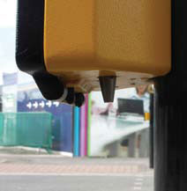

7.7.3 For consistency the tactile unit should be installed on the right hand side of the bottom of the push button unit.

7.7.4 Tactile devices cannot be fitted to junctions where there is a formal uncontrolled exit leading onto an unprotected signalised pedestrian crossing, or where the controller equipment excludes integral Red Lamp Monitoring facility. (TAL5/05 Part 3, TR2500A)

7.7.5 Audible equipment shall comply with TR2509A specification; only a single bleep output shall be used. Bleep and sweep is not used in London.

7.7.6 Audible equipment shall only be installed at junctions where a single phase output controls all pedestrian movements, i.e. an all-round pedestrian stage.

7.7.8 In sensitive residential areas it may be necessary to adjust the volume of audible equipment. Additionally, audible equipment can be inhibited using the time switch controller facility. Typically, audibles are switched off between the hours of 22:00 and 07:00 seven days a week, or other appropriate times.

### 7.8 Box Signs

7.8.1 There is no requirement for erecting a regulatory box sign to TSRGD 2002 Diagram 606 where an exclusive traffic movement is required at the signals, as indicated by a substitute green arrow. They should only be used in conjunction with a Traffic Regulation Order (TRO) associated with the stopline and attached to each of the primary and secondary signals.

Diagram 606 (TL, AO, TR)

7.8.2 The Designer should ensure with the Highway Authority that a TRO exists or is proposed for any box sign associated with the signals.

7.8.3 Ideally a Turn Left (TL) sign should be mounted on the left of the signal head, a Turn Right (TR) sign should be mounted on the right of the signal head and the Ahead Only (AO) sign should be mounted on right hand side of the nearside primary, and on the left hand side of the duplicate primary and secondary signal.

7.8.4 All versions of Diagram 606 may be mounted in 4-in-line configuration under the green arrow.

7.8.5 When required a No Right Turn (NRT) and No Left Turn (NLT) signs should be mounted on the relevant approach, on all signal heads alongside the green aspect. The NRT sign should be mounted to the right of the signal head and the NLT sign should be mounted to the left hand side.

Diagram 612 (NRT) Diagram 613 (NLT)

7.8.6 No U-turn (NUT) box sign should be mounted on the offside of the relevant approach. Ideally it should be mounted to the right of the signal head.

Diagram 614 (NUT)

7.8.7 The following exemption plates may be added:



Diagram 954.5 (EB) Diagram 954.6 (EB&C) Diagram 954.7 (EBT&C)

7.8.8 Permitted variants are:

For Diagram 954.5 – “Except cycles”

For Diagram 954.6 – “Except local buses” or “Except buses & taxis”

For Diagram 954.7 – “Except local buses & cycles” or “Except local buses & taxis”

7.8.9 It is possible to combine exemption plates with Diagram 606, but only if the green arrow aspect is replaced with a general green signal aspect.



7.8.10 In addition to the static Diagram 616 sign, a No Entry (NE) box sign can be installed on the back of traffic signal pole. NE box signs shall be lit and mounted on both sides of the restriction. It is advisable not to install NE box signs if the static Diagram 616 contains exemptions.



Diagram 616 (NE)

### 7.9 Siting Of Controllers

7.9.1 A controller shall be sited such that its position will allow unimpeded use of the footway by pedestrians, those using wheelchairs or pushing prams. It should allow the outercase door and panels to be opened to their full extent. When the doors are open they should not cause undue obstruction on the footway but there should be sufficient clearance for an operative to work. The controller should not obstruct other street furniture and should not mask waiting pedestrians from approaching vehicles (TD 50/04, Chapter 2).

7.9.2 When the controller is installed on unmade ground a concrete pad or paving slabs should be provided in front of the outercase doors to assist maintenance.

7.9.3 The controller should be sited so that when working at the controller an engineer should preferably be able to view the junction and the stop lines.

7.9.4 Allocated parking or hard standing area should be provided for maintenance company’s vehicles, particularly at roundabouts and gyratories where the controller may be sited in the middle.

### 7.10 Electricity Supply Pillars

7.10.1 Electricity Supply Pillar (ESP) should be located at the back of footway, close to a wall or fence where generally it will be safe from vehicular collision. It must not obstruct the footway or cause a trip hazard to pedestrians. It is not recommended to be positioned against guard railing in case this is removed at a later date.

7.10.2 ESPs should be located so as to allow safe isolation of the equipment following a traffic accident where the controller is damaged. It must not obstruct private property, doorways, accesses or shop windows.

7.10.3 If the ESP is located on the opposite side of the road to the controller, an additional isolating ESP should be installed close to the controller.

7.10.4 Traffic signal installations are limited to a 2kW incoming supply.

### 7.11 Maintenance

7.11.1 It is the Designer’s duty to consider maintenance issues during the design stage (CDM 2007).

7.11.2 The Designer must consider the impact of future servicing and decommissioning on the operation of the traffic signals equipment.

### 7.12 Street Clutter

7.12.1 A key component of the TfL Streetscape Guidance is to reduce the street clutter. This can be achieved by; mounting signals on street lighting columns; installing equipment tight against property boundaries on narrow footways; ensuring controllers and electricity supply pillars do not create obstructions to pedestrians and ensuring the number of signal poles and heads are not excessive, whilst maintaining safe visibility of the signals.

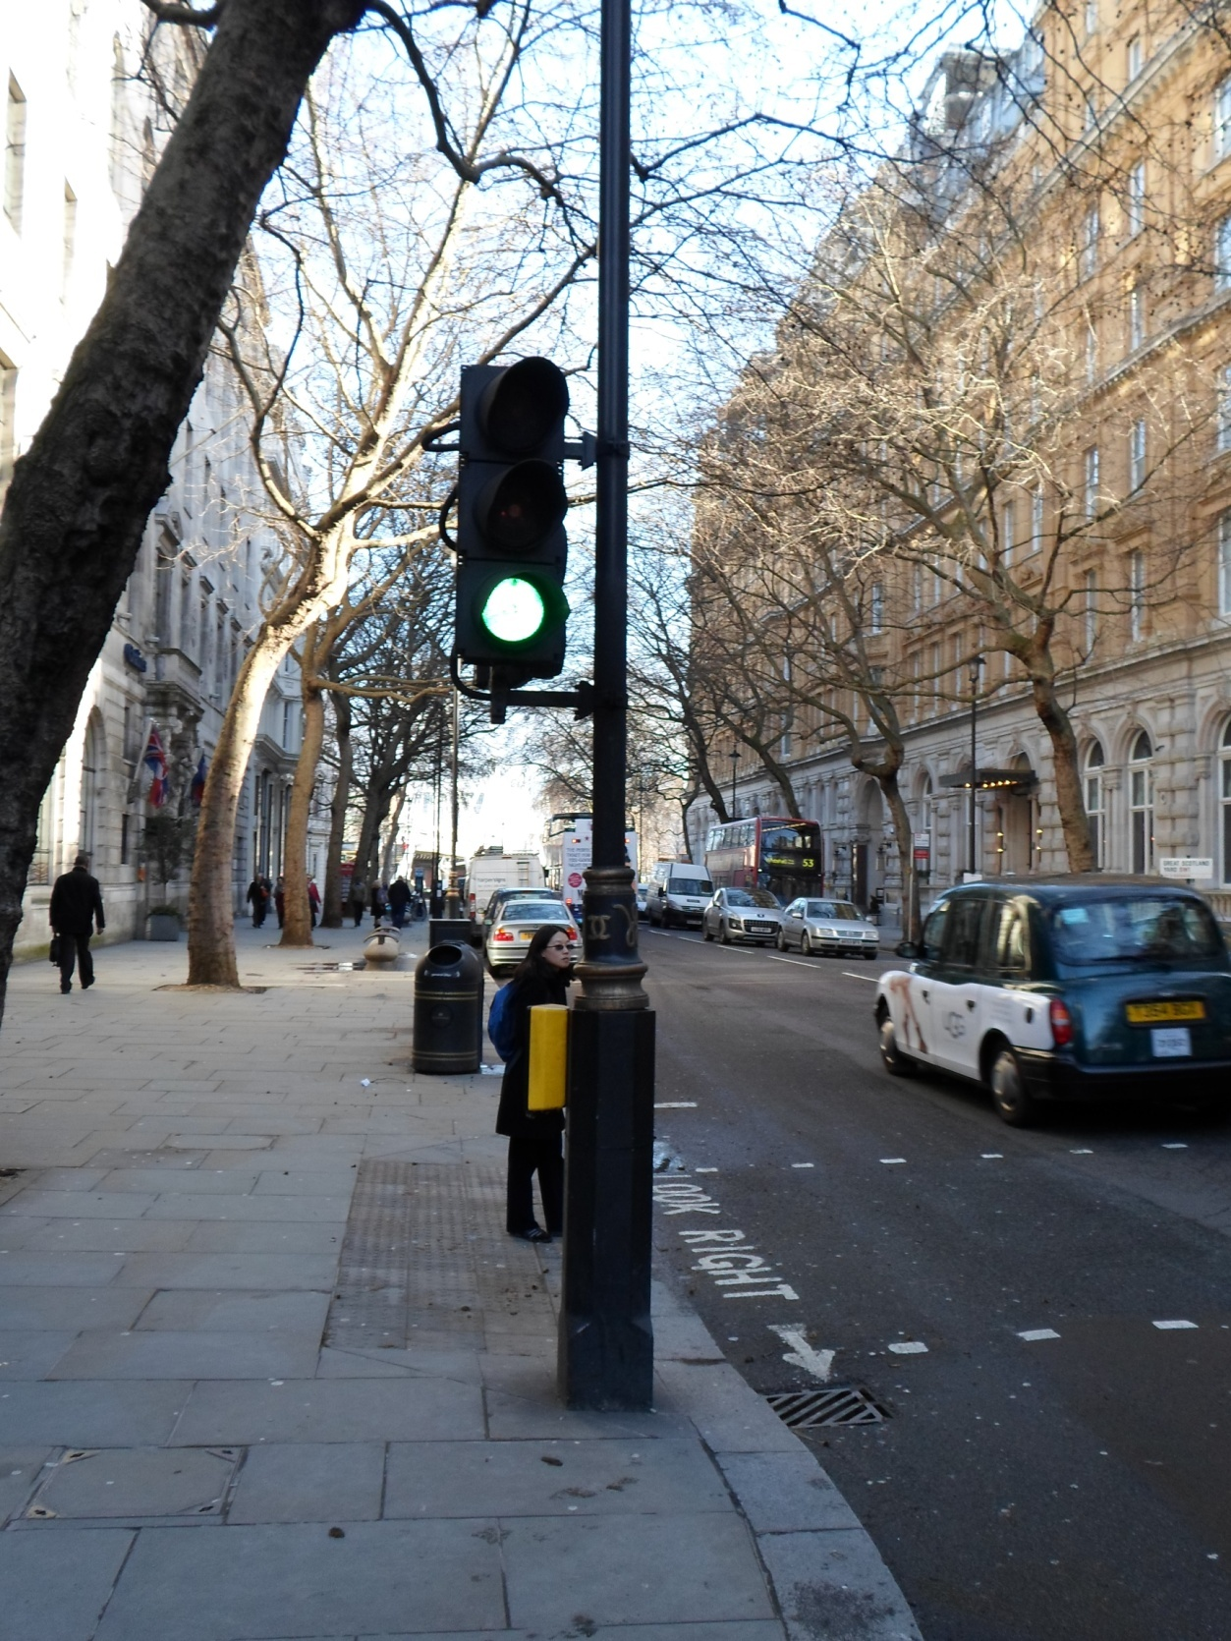

**8 Timing Periods**

8.1 Traffic signal controller timings should be as follows:

a) Recommended traffic green signal minimum 7 secs

b) Recommended cycle green signal min (RAG arrangement) 5 secs

c) Green Arrow minimum 4 secs

d) Minimum traffic to traffic intergreen 5 secs

e) Minimum intergreen prior to early cut-off 4 secs

f) Mandatory leaving amber (TR2500A) 3 secs

g) Mandatory starting amber (TR2500A) 2 secs

h) Minimum red signal duration presented to traffic 3 secs

i) Dummy phase minimum 1 sec

j) Minimum “blackout period” (TR2500A) 3 secs

k) Minimum farside green man signal (TAL 5/05) 6-12 secs

l) Minimum nearside green man signal (TAL 5/05) 4-9 secs

m) VA extensions for XYZ loops normally 1.6 secs

n) VA extensions for MVDs normally 0.4 secs

8.2 Extension values should be determined following site observations as traffic composition and behaviour may affect the values.

8.3 Maximum recommended cycle time (TAL1/06) 120 secs

8.4 In UTC areas, Network Performance decides the appropriate cycle time. For MOVA sites, the TOTALG should not exceed 120 secs. At signal controlled roundabouts a shorter cycle time of 60 seconds or less is recommended (LTN1/09).

8.5 Other considerations –

8.5.1 When deciding on the most appropriate cycle time, pedestrian density, behaviour and waiting times should be considered. In busy pedestrian areas, the recommended maximum cycle time is 90 seconds.

8.5.2 Pedestrian Countdown at Traffic Signals Junctions (PCaTS) – Road Trial Report (TRL Project Report, TfL 2481) found over 54% of pedestrians crossed within 5 seconds of arriving at a crossing, 70% crossed within 15 seconds and 85% within 30 seconds, regardless of the pedestrian signal being displayed. Although it isn't illegal for pedestrians to cross while the red man is showing, in 2010, 20% of all fatal and serious pedestrian injuries in London took place near pedestrian crossings.

8.5.3 There is flexibility in the interpretation of the Green-Man invitation period for signal controlled junctions. The following statement is the basis for pedestrian timings and is consistent with DfT guidance.

“Pedestrian timings should enable waiting pedestrians (who commence their crossing at some point during the invitation period) to cross the carriageway in a single movement, without stopping or turning back.Waiting pedestrians are further defined as the standing queue of pedestrians as observed at the start of the green-man”

The process that determines the pedestrian invitation timings can be found in SQA 645 “Traffic Signal Timings”

8.5.4 Intergreens – See SQA-0645

9 OFFSET CROSSING POINTS

9.1 Offset crossing points are often used to increase junction capacity. It is important to consider the safety aspects of such installations and ensure the release point is correctly configured in the controller.

9.2 Such crossing facilities should be sited so as to give sufficient visibility of signals to vehicles turning onto the crossing, and to provide sufficient stacking space, so as not to impede other traffic streams. The Designer must also consider see-through issues and driver confusion caused by the multiple signal sets.

9.3 TI Engineers shall determine the safe release point of the pedestrian movement and include linking measures in the controller specification. The decision shall be taken following site observations, modelling outcome and discussions with NP Engineers.

10 Choice of Method of Operation

10.1 General

10.1.1 It is important the Designer considers the strategic policy framework (Mayor’s Transport Strategy document 2010) and, where possible, incorporate the requirements of all highway users including pedestrians, cyclists, persons with specific mobility requirements and public transport. It is worth noting that the Traffic Management Act 2004 (Part 2, Section 31) considers pedestrians as traffic.

### 10.2 Central/Local Operation

10.2.1 In London, a large proportion of junctions operate under Urban Traffic Control (UTC) (or central computer control) using a Split Cycle Offset Optimisation Technique (SCOOT). The decision as to whether a site should operate UTC SCOOT is made by Network Performance.

10.2.2 In situations where UTC mode is configured in the traffic signals controller, this shall be the highest mode of operation with a fallback mode being either Cableless Linking Facility (CLF), Vehicle Actuation (VA), or Microprocessor Optimised Vehicle Actuation (MOVA). It shall be possible to mix fallback modes, for example, CLF mode operating during the peak periods and MOVA or VA modes during the off peak period, or at night.

10.2.3 SCOOT information is provided by Network Performance and includes detector locations and the necessary infrastructure. Cabled systems require ducting information; wireless systems require street furniture information for the transmission units.

10.2.4 In areas outside central computer control, Traffic Infrastructure shall make the decision as to the most appropriate mode of operation. VA mode should be considered first, as it is a flexible and easy to maintain system. MOVA should be considered on; high volume, multilane approach routes; locations with red compliance problems; sites where 85th percentile approach speeds are 45mph or higher; or with 50mph speed limit and sites where additional capacity is required (TD 35/06).

NB: Compact MOVA (CMOVA) is an alternative system to full MOVA. Trials have shown that, although not quite as effective as a full MOVA system, Compact MOVA is capable of reducing delay compared with traditional VA (TAL1/06 Part 2 of 4).

10.2.5 In VA mode a minimum of four MAXSETS shall be determined. An example of best practice is shown below.

MAXSET A – AM peak (typically 06:00-09:30)

MAXSET B – off peak / lunch time

MAXSET C – PM peak (typically 15:00-19:00)

MAXSET D – overnight

10.2.6 In CLF mode, the following Network Performance convention should be followed.

Plan 1 – AM peak

Plan 2 – Off peak

Plan 3 – PM peak

Plan 5 – Overnight

Plan 8 – Late evening

CLF plans will need to replicate the UTC plans as closely as possible, and these plans will be provided as part of the SQA 448 process.

10.2.7 Additional MAXSETS and CLF plans are available and can be used for special events, at the weekends, outside schools etc.

10.2.8 It is preferable to determine Stage 1 as the major road. Best practice allocates pedestrian stage early in the controller cycle with side roads appearing last.

10.2.9 Prohibited/Ignore/Via moves tables should be used to stop unsafe stage changes, for example through incorrect termination of the right turn indicative or filter signals, or where there is a possibility of the controller locking up. In Manual mode, ‘stages shall be served as requested by the operator’ (TR2500A) and prohibited moves must be defined in a stage moves matrix for this mode. Any condition that would prevent a stage in other modes shall also be inhibited.

10.2.10 Stage revert facility should be configured in all controllers. In the absence of demands, the controller should rest on the main stage (typically Stage 1), or the controller all-red stage (typically Stage 0). Reversion to an all-red stage should be considered on shuttle working sites or high speed roads where approach speeds are a concern. However, on multiple lane approaches, swift changes from red signal may pose a threat to crossing pedestrians.

10.2.11 Start Up controlled sequence shall run every time signals are restored and include the manual panel lamps on/off switch. For details of the sequence, see TR2500A.

10.2.12 The Start Up Stage should run the main traffic movements, on high speed roads this should be the stage with the highest approach speeds. For roundabouts, circulatory traffic movements should be included.

10.2.13 The Holiday Clock facility can be used to determine special timing sets e.g. Christmas, Easter, holiday periods and one off events. Examples of use are supermarket junctions, junctions at out of town shopping centres and other busy shopping locations during Christmas.

### 10.3 Leaving amber link (L/A) –

10.3.1 For all locally controlled sites where the controller is running MOVA/VA/Fixed Time/CLF/Hurry Call/Priority modes the L/A link shall operate on a permanent basis. The L/A link conditioning shall include a statement to call the relevant demand dependent stage (or phase) associated with the L/A release window. This is achieved by inserting an additional controller demand.

10.3.2 An exception to the above are Manual and Linked Fixed Time modes where the L/A stages are defined in the multi stream operation with their appearance fixed and associated with the main stream stages.

10.3.3 For centrally controlled sites, NP Engineers may override this facility by transmitting the relevant UTC control bits. However, once UTC mode is lost, the controller shall revert back to the L/A link facility.

NB: It is advisable not to include the offset crossing details in CLF plans.

10.3.4 The TI Engineer should attempt to design out the use of the override timer, but where this is unavoidable the Engineer must ensure the override timer value is greater than the maximum possible cycle time.

### 10.4 Early Cut Off/Late Start Operation

10.4.1 Early cut-off operation (e.c.o.) is acceptable, but only if,

1. The opposed movement features a closely associated signals layout;
2. A prohibited right turn Traffic Regulation Order exists and is enforced by box signs;
3. The right turn movement is not possible.

10.4.2 Late start operation is not permitted except when applied in specific circumstances such as priority systems, or where the approach with the early start is not able to turn right, either due to a road layout, or the right turn movement is prohibited by means of a Traffic Regulation Order.

11 Modelling

11.1 The detailed analysis of the performance of a traffic signalled junction is helped by the use of modelling programs such as Linsig, Transyt or Vissim. The use of a computer program shall always be considered as an aid to the design of an individual junction or network. Additional factors must be taken into account to achieve a good design, such as turning radii, lane widths, visibility, signing, environmental considerations and specific site knowledge.

11.2 Scheme promoters are expected to provide the necessary information and liaise with NP Engineers throughout the Modelling Audit Process (Traffic Modelling Guidelines, TfL).

11.3 The Model Auditing Process (MAP) is designed to give a common structure f or all model submissions and is made up of six common stages:

Stage 1- Scheme & Network Scope Checkpoint Meeting

Stage 2 - Calibrated Base Model Submission

Stage 3 - Validated Base Model Submission

Stage 4 - Proposed Models Checkpoint Meeting

Stage 5 - Proposed Models Submission

Stage 6 - Submission of Traffic Signal Supplementary Report to

Promoter

11.4 Specific MAPs are available for Linsig (LMAP), TRANSYT (TMAP) and VISSIM (VMAP) modelling software.

11.5 The TI Engineers and NP Engineers shall complete SQA-0448 form for all projects requiring a revised traffic signals controller specification. The information includes proposed staging, operation and safety timings, and is essential for a successful MAP, Stage 5 submission.

11.6 Once the proposals are approved, and the SQA448 form has been jointly signed by TI and NP, then the TI Engineers can then start the traffic signals design and progress the scheme through to completion.

12 Additional Controller Features

12.1 It is possible to incorporate third party equipment within traffic signals controllers and allow the traffic signals controllers to interact with such equipment or simply forward on the relevant messages. Examples of successful deployment of third party equipment include, access control, railway crossings, security and emergency services display panels.

12.2 All third party equipment requires a common interface point that is accessible to all parties, often this is a separate cabinet fitted with key operated locks available to all maintenance contractors.

12.3 If third party equipment is to be deployed, the Scheme Promoter is required to provide TI Engineers with copies of the relevant approvals and ensure TI Engineers’ early involvement at the design stage.

12.4 At critical UTC junctions, NP Engineers may specify additional control measures, these include:

a) UTC Controllable All red stage -

The all red stage is configured in addition to the controller all red stage. It is advisable the working duration of the all red period is at least 3 seconds.

b) Contingency stages -

Often these are repeated stages with restricted movements (certain pedestrian or traffic phases are omitted). TI Engineers shall make the final decision as to which stage to stage movements are allowed and which should be prevented.

c) Traffic Management measures (ATM, SASS, Queue detection, SCOOT Gating) -

The use of additional detection allows NP Engineers to run different plans, for example, to hold traffic away from the congested town centre, or to deal with a public event.

13 Traffic Signals Controller Specification

13.1 All traffic signals controller equipment shall comply with TR2500A requirements. For traffic signal installations, the System Requirements Specification (TA84/06) is provided by the controller specification. In London, all junction controller specifications must be audited before being issued to the equipment manufacturer, further details of the auditing process can be found in SQA-0646.

13.2 With the exception of Red Light Camera sites, Extra Low Voltage (ELV) controllers powering LED signals should be specified for schemes where a new controller is required.

13.3 The following controller facilities are available:

a) Manual mode -

All controller stages shall be configured with the exception of ad hoc/contingency stages. Only suitably qualified personnel shall have access to Manual Panel operation (Handset command restriction).

b) UTC mode -

London uses a bespoke front end SCOOT UTC system, it is based on

MCE0360C and MCE0361A principals. The associated controller hardware must conform to TR2523 specification. A dedicated telecommunications data line is required for communications.

c) Cableless Linking Facility (CLF) -

The majority of CLF plans use immediate, demand dependent and hold stage influences. Additional influences can be used to optimise junction performance. Example of such use is the VA logic within CLF, allowing controllers to terminate a stage early or add another stage.

Traffic detection is required when employing VA logic within CLF.

d) Vehicle Actuation -

Majority of traffic approaches should feature ‘demand and extend’ controller inputs. Exceptions include private accesses, cycle movements etc.

If VA mode is the normal mode of operation, it is a good practice to

provide at least two controller inputs per traffic phase.

e) Fixed Time to current maximum -

This is available as a fall back mode which enables demand dependency for stages and phase maximums consistent with the timetable.

f) Fixed Time mode -

Simple Fixed Time and Linked Fixed Time are an alternative fall back to Fixed Time to current maximum. There is no demand dependency for stages as the stage sequence is fixed.

g) Light Rapid Transport (LRT) mode -

It is used on Croydon Tramlink, a 28.2Km light rail system running a mixture of street track shared with other highway users, dedicated track in public roads, off-street track, and one section shared with a [third rail](http://en.wikipedia.org/wiki/Third_rail) electrified [Network Rail](http://en.wikipedia.org/wiki/Network_Rail) line. The requirement for the use of tram priority is outlined in Croydon Tramlink Act 1994.

Only suitably qualified personnel are allowed to work on Croydon Tramlink.

h) VA Priority mode –

Used by iBus equipment to provide selective vehicle priority at locally operated junctions.

VA Priority facility is not used in UTC.

i) Hurry Call mode –

Used to help Emergency Services, and in situations where progression is an overriding consideration.

j) Part time mode –

The mode is controlled either via a time switch or queue loop logic.

k) Integral Monitoring Unit (IMU) –

All locally controlled traffic signal installations require a Public Switched Telephone Network (PSTN) telephone line and IMU.

l) Lamp monitoring –

All junction controllers shall be capable of red and general lamp monitoring. Red lamp monitoring shall be used with pedestrian phases and configured to disable the appearance of green man (TR2500A).

At roundabouts, part time and shuttle working installations, red lamp failure shall extinguish all lamps.

All box signs shall be monitored with failures generating a lamp fault.

m) Detector Fault Monitoring (DFM) –

All detection shall be monitored for failures. The following periods are typical values used in London:

i) Traffic detection 30 mins active, 18 hours inactive (72hours for car

parks etc)

ii) Push button units 30 mins active, 96 hours inactive (extendable to 255

hrs if required)

iii) Pedestrian detection 60 mins active, 18 hours inactive

iv) iBus controller input 3 mins active, 168 hours inactive

n) Ripple change facility –

Ripple change facility is not used in London.

14 Special Facilities

14.1 Public Transport Priority

14.1.1 In London public transport priority is based on automatic vehicle location (AVL), also known as iBus. iBus equipment belongs to TfL Buses and is installed in traffic signal controllers.

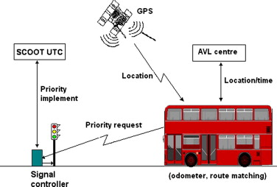

14.1.2 iBus traffic signal equipment is designed to wirelessly communicate with the approaching bus and interface with the traffic signal controller. The traffic signals controller specification defines the level of priority and allows either the extension of green signal, should a bus be detected, or permit a recall of the green signal should the signal be on red. In situations where there are too many buses, for example near bus garages, it is possible to impose constraints at certain times of day.

14.1.3 If there are bus routes passing through a junction, TI Engineers shall follow a site suitability process to determine if bus priority is necessary, and incorporate bus priority details in traffic signal controller specifications.

14.1.4 At locations where there is existing iBus equipment installed, as part of site works, TI Engineers shall ensure the equipment is transferred and left in operational state following the works.

14.1.5 For brand new junctions, TI Engineers shall incorporate design / procurement / installation and commissioning of iBus equipment into traffic signal works. All costs associated with the additional equipment shall be covered by the Scheme promoter.

15 Light Rapid Transport (LRT)

15.1 ‘Tramway’ refers to a system of transport used for the carriage of passengers, employing parallel rails which provide support and guidance for vehicles carried on flanged wheels.

15.2 When tramways are incorporated into traffic signals layout, additional controller facilities shall be configured in the controller. The LRT mode needs to be set as the higher mode of operation offering a form of priority over other road users. The level of priority is agreed between the tram operator, the highway and traffic authorities.

15.3 Tram aspects must conform to TSRGD 2002 Diagrams 3013, 3013.1, 3013.2, 3013.3, 3013.4 and 3013.5, and can be mounted next to traffic signals as prescribed in Table combinations for signs 3000.7, 3000.8, 3000.9 and 3000.10.

15.4 More information on tramways design can be found in Guidance on Tramways published by the Office of Rail Regulation.

16 Wig Wags (TAL1/08)

16.1 TSRGD 2002 Regulation 39 permits the use of Diagram 3014 for the control of road traffic at swing or lifting bridges, tunnels, airfields or in the vicinity of premises used regularly by fire, police or ambulance service vehicles. A narrower version of wig wag signal is available (NP 3015) but needs sign authorisation.



Diagram 3014

16.2 TR2513A Performance Specification for Wig Wag Signal Control Equipment outlines operational requirements.

16.3 Wig Wags installation is very similar to traffic signalled junction, using 4m standard poles and junction controller running a special Wig Wag configuration. Designer shall adopt the junction design process when working on a new Wigwag installation.

**17 References**

Construction (Design and Management) Regulations 2007 (CDM 2007)

Croydon Tramlink Act 1994

Design Manual for Roads and Bridges (DMRB)

Disabled Persons Act 1981

Greater London Authority Act 1999

Guidance on the use of tactile paving surfaces (DfT 2007)

Guidance on Tramways (ORR)

HD 28/04 Skid Resistance

Inclusive Mobility: A Guide to Best Practice on Access to Pedestrian and Transport Infrastructure (DfT 2002)

London Accident Analysis Unit Report ATWP25 and ATWP37

London Cycling Design Standards

LTN 1/09 Signal Controlled Roundabouts

LTN 1/86 Cyclists at Road Crossings and Junctions

LTN 1/97 Keeping Buses Moving

LTN 1/98 The Installation of Traffic Signals and Associated Equipment

LTN 2/95 The Design of Pedestrian Crossings

LTN 2/08 Cycle Infrastructure Design

MCE0181 Issue A Siting of Inductive Loops for Vehicle Detecting Equipments at Permanent Road Traffic Signal Installations

MCE0360 Issue C: Urban Traffic Control Functional Specification

MCE0361 Issue A: High Capacity Data Transmission System for use In Urban Traffic Control Systems

Signing the Way (DfT Traffic Signs Policy Paper October 2011)

TA 57/87 Roadside Features

TA 68/96 The Assessment and Design of Pedestrian Crossings

TA 90/05 The Geometric Design of Pedestrian, Cycle and Equestrian Routes

TA 91/05 Provision for Non-Motorised Users

TA 12/07 Traffic Signals on High Speed Roads

TAL 1/06 General Principles of Traffic Control by Light Signals

TAL 1/08 Wig-wag Signals

TAL 1/12 The Traffic Signs (Amendment) (No.2) Regulations and General Directions 2011

TAL 2/03 Signal-control at Junctions on High-speed Roads

TAL 3/03 Equestrian Crossings

TAL 16/99 The Use of Above Ground Vehicle Detectors

TD 9/93 Highway Link Design

TD 42/95 Geometric Design of Major/Minor Priority Junctions

TD 50/04 The Geometric Layout of Signal-Controlled Junctions and Signalised Roundabouts

TD 35/06 All Purpose Trunk Roads MOVA System of Traffic Control at Signals

TfL Traffic Modelling Guidelines

The Traffic Signs Regulations and General Directions 1994 (TSRGD 1994)

The Traffic Signs Regulations and General Directions 2002 (TSRGD 2002)

TfL Signal Design Memorandum – No.002 ASL to Stud Distances on Cycle Routes

TfL Signal Design Memorandum – No.003 Monitoring of Box Signs

17 References (continued)

TfL Streetscape Guidance 2009: A Guide to Better London Streets

TR2206 Issue A: Specification for Road Traffic Signals

TR2500 Issue A: Specification for Traffic Signal Controller

TR2505 Issue A: Performance Specification for Above Ground Vehicle Detector Systems for use at Permanent Traffic Signal Installations

TR2508 Issue A: Performance Specification for Tactile Equipment for use at Pedestrian Crossings

TR2509 Issue A: Performance Specification for Audible Equipment for use at Pedestrian Crossings

TR2513A Performance Specification for Wig Wag Signal Control Equipment

TR2523 Issue A: Traffic Control Equipment and Interfacing Specification

Traffic Signs Manual Chapter 3, Regulatory Signs

Traffic Signs Manual Chapter 5, Road Markings

**18 Structure**

The documents listed below form a set of guidance and procedures for the design of traffic signals and signal junctions in London:

SQA-0640 Policy, Standards and Guidance to Procedures for the Design of Traffic Signals

SQA-0641 High Level Process for the Design of Traffic Signals

SQA-0642 Client Requirements

SQA-0643 Design for Signalised Junctions

SQA-0644 Design for Stand Alone Crossings

SQA-0645 Traffic Signal Timings

SQA-0646 Safety Auditing of Signal Schemes

SQA-0647 Justification for Traffic Signals

SQA-0648 Documentation for the Design File

**19 Document Control**

| Issue | Date | Change Summary | Author | Checker | Approver |
| --- | --- | --- | --- | --- | --- |
| 1 | June 2013 | Previously incorporated in SQA-0064. Issued for use. | K Van Tuyl | S Poole | A Scriven |
| 2 | Aug 13 | Revised following consultation | K Van Tuyl | S Poole | A Scriven |

**Appendix A - Traffic Signal head arrangements and clearances.**



